RS steganalysis of ARM-m is implemented by “mainARM_RSsteganalysis21102025.m” where you specify modulo value and size of the blocks (number of rows and columns). Threshold asked shall be 0. ARM-m is called in line 254. Calculation of RS sets is done in “RSsteganalysis30042018.m” called in line 306. Plotting of the diagram is made in line 316.

Screenshot of the working program after outputting RS diagrams for Baboon is given in Fig. 1 below

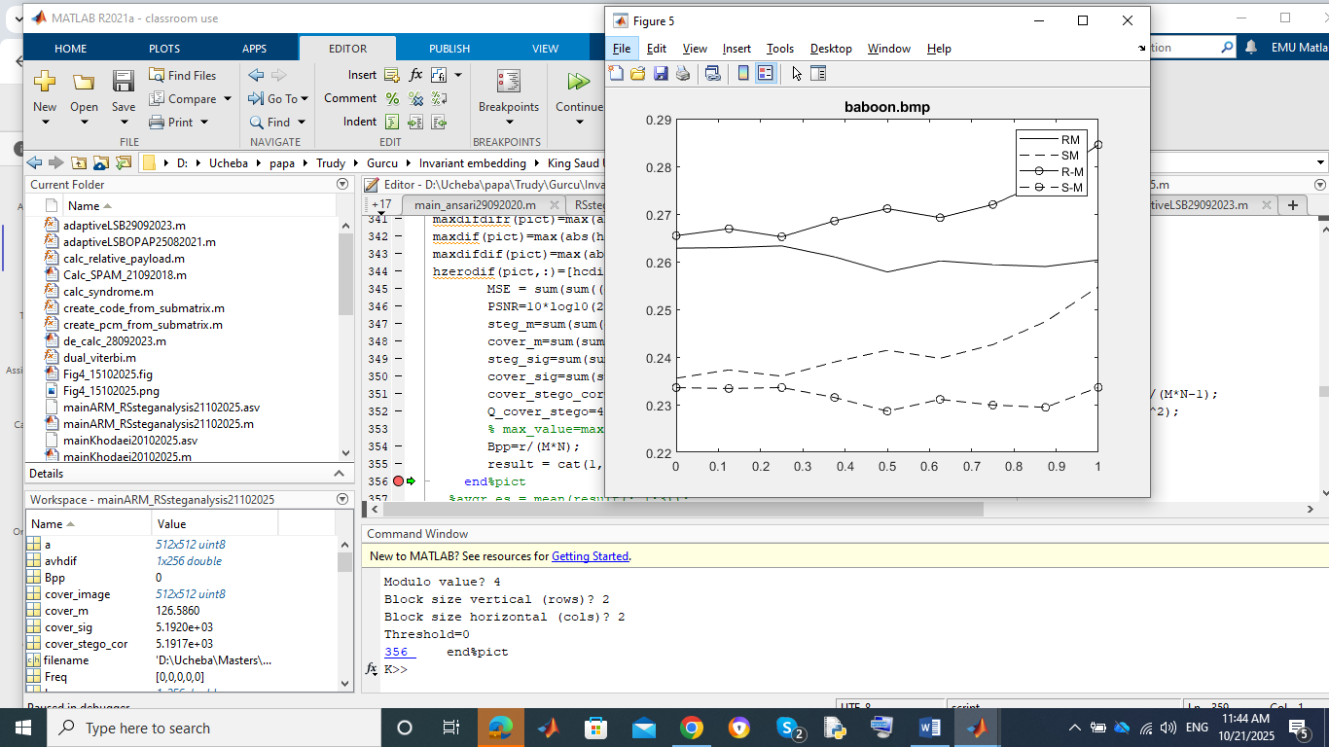

Fig. 1/ Screenshot of running mainARM_RSsteganalysis21102025.m